GDPR’s impact on Facebook

Poster assignment (10%)

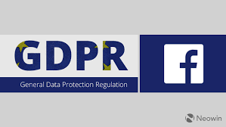

Information Systems Management

Bshtm4

2018/2019

Presented by: Charlene Moore

# 

(lucidpress, 2018)

# INTRODUCTION

Facebook is a social networking service founded by Mark Zuckerberg in 2004. In the space of 14 years Facebook has grown to be the largest social network in the world with more than two billion users. Facebook users are active user’s majority accessing their accounts daily. Facebook has purchased many different companies during its success over the years. Some of these companies are Instagram, purchased in 2012 and WhatsApp in 2014. By purchasing these companies Facebook has eliminated its biggest competitors, all being the biggest social networks in the world to date. Unfortunately, Facebook success is at risk due to it’s recent data breaches, causing 50 million user accounts being affected. I will conduct a SWOT analysis to identify Facebook’s internal strengths and weaknesses and external opportunities and threats. Businesses may use a SWOT Analysis to identify a company’s future performance and help make strategic business decisions.

# SWOT

## STRENGTHS:

Facebook’s greatest strengths are their integrated features of Web2.0 under the one roof and their huge fan base. The two main benefits of Web2.0 is “increased knowledge sharing and more effective marketing” (McKinsey & Company, 2018) and lower costs.

Facebook is user friendly and a great social networking site for families and friends to network. Facebook allows users to share photos, videos, and provides a messenger service for a private conversation between users. Facebook had recently added new features like the option to post stories, and a sales page for companies to advertise their businesses and users to buy and sell goods. The aim is for all of this to be done securely.

Facebook has security options for their users. Users can have their accounts more private than others. E.g. Some users have their accounts private. Meaning only their friends can see their profile and the content they post. Other accounts are public, allowing all Facebook users access to their accounts.

## WEAKNESSES:

Facebook have failed on more than one occasion in delivering a secure service as they promised. Since May 2018 over 50 million users have been affected by data breaches. The General Data Protection Regulations has pushed companies like Facebook to be safer in how they store, share and gather their data. Facebook has failed in meeting the standards set by GDPR, as a result facing many fines.

Social Medias greatest weakness is Cybercrimes and errors in Authentication of Users. Robust Security and strong systems potentially could reduce these threats massively.

## OPPORTUNITIES:

Facebook possesses opportunity to continue being the world’s social networking superior with owning three of the biggest social networks in the world. Being in control of Facebook, Instagram and WhatsApp is an opportunity to support each other and compete against other social media without them being a serious threat.

Facebook can purchase more companies and team up with companies like LinkedIn.

## THREATS:

It’s Facebooks responsibility to ensure that the security settings users choose for their accounts are secure and strong enough to protect their data they post on their accounts from hackers and fake accounts seeking to steal user’s information to create fake accounts to personate other users.

Currently Facebooks biggest threat is hackers. Experiencing data breaches as big as Facebook has, potentially threatens its users trust in their service. If Facebook doesn’t rectify their Data breaches and ensure that history doesn’t repeat, it potentially could destroy them.

Storing their data together can be a strength and a possible Threat. Data Breaches have bigger impact.

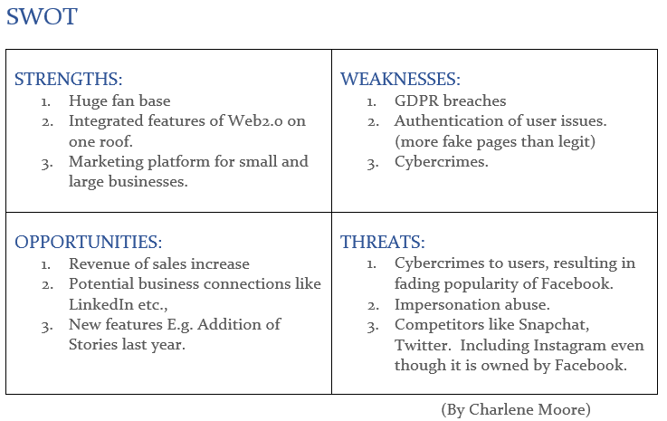

cONCLUSION

Facebook is an excellent service with many great features and services. But, if users can’t trust their data to be secure they will stop using their services. This will give opportunity to external threats like Snapchat. Facebook must face their fines for the breaches they have encountered and work on preventing any more in the future.

BIBLIOGRAPHY

* (McKinsey & Company, 2018)`How companies are benefiting from Web 2.0: McKinsey Global Survey results`, McKinsey & Company, [online] Available at: <https://www.mckinsey.com/business-functions/digital-mckinsey/our-insights/how-companies-are-benefiting-from-web-20-mckinsey-global-survey-results> [Accessed 02 Nov. 2018].
* Facebook GDPR Poster created using: (lucidpress, 2018) [online] Available at: <https://www.lucidpress.com/>